Do Unrelated visual stimuli effect the retention of audible information
1903299 Connor Murphy
MSc Applied Artificial Intelligence and User Experience

PSY555: In What Ways Are We All The Same?

Dr. P George Lovell
October 9, 2024

Do Unrelated Visual Stimuli effect the Retention of Audible Information

Abstract
The report aims to answer the question of whether a person who views a lot of “shorts” type content online, performs better in regards to retention of audio information when an unrelated visual accompanies it. This question was answered by creating 4 audio stories designed to be similar to blog style content found on TikTok or Similar. These were accompanied by visuals that acted as an unrelated distraction. These distractors varied in their levels of distraction from high, medium, low to zero. Each participant was shown all 4 stories with varying distractors using the Latin square counter balancing method. After each video the participant was asked to answer questions relating to the story, designed to test their retention of the information within that story. To end the experiment the participant was given the short form video addiction scale developed by Louis Leung for his 2008 paper Leung, L. (2008). With this, the participants were split into high and low social media use. When this data was tested for significant difference, it was found that there was a significant difference between the stories themselves but no significant difference was found between the levels of distraction. When the data was tested against the two levels of social media use no significant difference was found. Suggesting that the only significant difference in the results was the difficulty of the questions relating to the stories. Also, that high level social media users have yet to develop any higher level of skill to pick out audio information when viewing an non-related visual. This is most likely due to the brain processing speech and visual information using two distinct systems according to the working memory model.

Results
As the type of statistical test, needed are highly dependent on the type of data being tested and how the data set are related, a brief overview of the experiment structure is needed.
Experiment structure
The experiment consisted of a participant watching and then answering multiple choice questions on 4 videos with 4 different scenarios described, in the form of a blog-style short. The video consisted of the audio of an AI voiceover telling a one minute long story and the visuals shows some stimuli unrelated to the story. The stories were voiced by an AI to keep a consistent tone. Great care was taken to design the stories in such a way that the difficulties of answering questions were similar and that they weren’t too long or short to ensure the participants had enough time to collect important information, but not so long that they would lose interest. After the participant had watched a single video, they were shown short washer videos to scrub their short-term memory before asking the questions. This way the participant is being tested on the knowledge they retained from the video, not the short-term memory. The audio for the 4 videos was constant so the independent variable was the visuals that accompanied the audio, with the dependent variable being the number of correctly answered questions. There were 4 levels of distraction were, High (a game of subway surfer), medium (a mime), low (calm ocean waves) and none (a grey square). To avoid order effects, the Latin Square counterbalancing method was used to determine the order of the videos and which video would have which level of distraction. With a total of 36 participants, there were enough participants to collect sufficient data on each combination. Finally, the participant undertook a questionnaire to measure their level of social media use.

Data Processing
As the data gathered from the experiment is in the form of answers to 7 multiple-choice questions regarding the video itself and the distractors, as well as a 17-question questionnaire regarding social media use, it will need to be properly encoded. The participant's personal data also needs to be obscured. Pavlovia, the software used to run the experiment automatically assigns a random 6-digit ID. However, one participant was able to use his real name due to an oversite in development. Their data was deleted according to ethical and legal guidelines along with any participant with blank data meaning that they stopped the experiment. With data cleaning completed the multiple-choice answers needed to be properly encoded, using binary system with 0 for incorrect and 1 for correct. Then the average number of correct answers for all audio and distractor pairs was calculated. Furthermore, the dataset was split into the mean value of answers for a particular audio story and the mean value of answers for a particular level of distractor. Next the questionnaire needed to be totaled. The sum of each participant’s answers was calculated and then checked against the mean value of the questionnaire. If the participant scored below the mean they were assigned low social media usage. If they scored above, they were assigned high social media usage.
Data Exploration
Primarily focusing on normality tests, statistics and histograms/Q-Q plots for each feature were found and plotted, (seen across the appendix). The normality test chosen was the Shapiro-Wilk test due to the number of data points for each feature being below the agreed-upon 50-point limit. The test revealed a mix of normal and non-normal distributions for all data sets as such a non-parametric significance test was needed to properly test the data. The data for the audio and distractors are within design as every participant tested each variation of the data and the 4 features being tested. The Friedman test was used, however, splitting the data into two distinct groups with high and low social media usage creates a between-subjects design as such a Kruskal-Wallis H test was used for this data.

Test results audio distractor
There was a statistically significant difference was found between the number of correct answers for the audio stories, χ²(36) = 24.968, p = <.001.
There was no statistically significant difference was found between the number of correct answers for the differing levels of distractors, χ²(36) = 2.962, p = .400.
Test results High Low social media usage
A Kruskal-Wallis H test showed that there was no statistically significant difference in answers of high and low social media uses for audio 1, χ²(1) = .623, p = .430, audio 2 χ²(1) = .799, p = .371, audio 3 χ²(1) = .450, p = .502 or audio 4 χ²(1) = .893, p = .345,
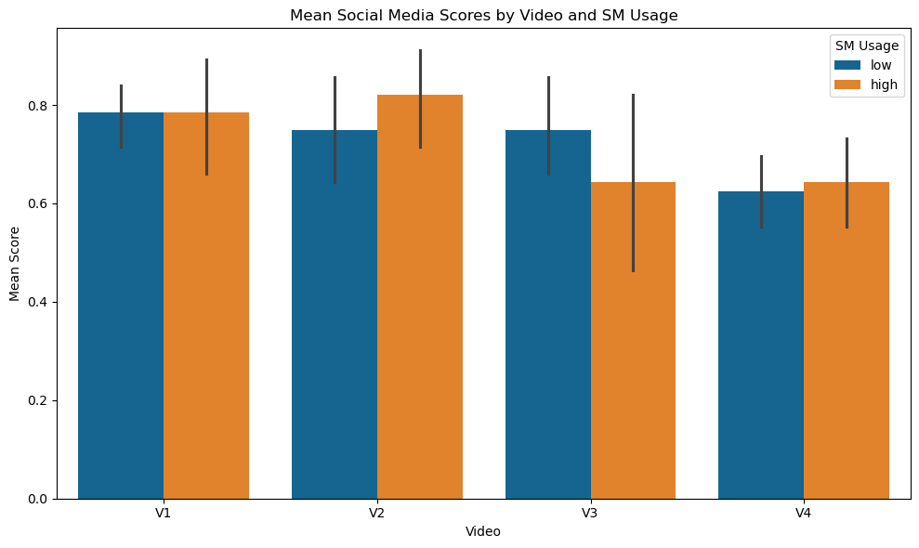
Figure 1 bar graph comparing the answers for high and low social media users on the videos
A Kruskal-Wallis H test showed that there was no statistically significant difference in answers of high and low social media uses for distraction level 1, χ²(1) = .560, p = .454, distraction level 2 χ²(1) = 2.875, p = .090, distraction level 3 χ²(1) = .041, p = .840 or distraction level 4 χ²(1) = 1.095, p = .295,
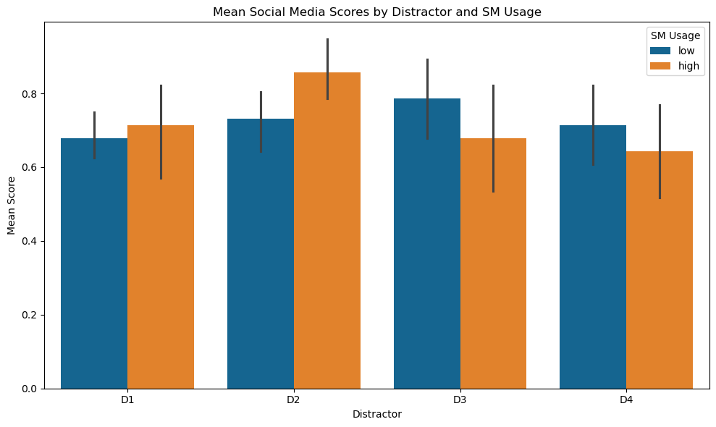
Figure 2 bar graph comparing the answers for high and low social media users on the levels of distractors

Discussion
To Summarize, the testing results found that the answers to the four stories showed significant difference, with story four specifically being the worst answered, suggesting that the stories had differing levels of difficulty. No significant difference was found between answers with respect to the different levels of distraction, suggesting that either the distractors didn’t affect the participant’s ability to answer the questions, or all the levels of distraction affected the participants to the same extent. Lastly, no significant difference was found between the answers for high and low social media users regarding different stories or distractors, disproving the hypothesis of this report.
The research question of this report was born from the findings of a paper by Yuhan Chen in which they explore the effects of short-form video addiction on a person’s ability to pay attention. According to their findings people with the addiction “suffer more difficulties maintaining attention, have more attention deficits … and have impaired attentional concentration for processing interference” Chen, Y., (2022). A distinctly unhealthy finding yet it provides an opportunity. A trend with these shorts is to have a main audio track or clip and then add an unrelated visual supposedly to combat the shortened attention span found by Chen. To a new user, this looks like an unintelligible mix of information but to an experienced user, they can discern the important information easily. Evidencing the development of a behaviour or skill however the results of this report have disproven this notion.
As the results section showed, the only significant difference found was between the answers given for the stories themselves. With 4 having the lowest rate of correct answers given. As the stories were shown to the participants through a Latin square method the drop is not due to fatigue or the like. The most plausible explanation then is that the difficulty of the questions for this story were higher. However, this should not affect results overall as the comparison between high and low users is compared between each individual feature not as a whole. As shown by figures 1 and 2 high scored both above and below for both the individual stories and levels of distraction. The notion of adding unrelated visuals may hold merit as high social media users scored the highest correct answers for distraction level 2 the ocean waves, but fell off as the distraction level increased, further research is needed to prove this notion.
The above findings can be best explained by the largely accepted working memory model. The specifics of the model have been highly disputed, but the working memory model has four main systems. The most important for this report is the phonological loop focused on speech, the visuospatial sketchpad concerned with visuals and spatial information, then the episodic buffer that combines data from the phonological loop and the sketchpad to create coherent complex episodes before getting stored in long term memory. According to Eysenck and Keane the episodic buffer “accounts for our ability to integrate different kinds of information in working memory” (Eysenck & Keane, 2020). As audio and visual data are handled by two distinct systems it should not matter which visual distraction accompanies the story as it is not interfering with the phonological loop. This means that the variation seen in the results is the natural ability of participants to pick out details in a person’s speech which didn’t change significantly between participants. The evidence for these two distinct systems is Michele Gloede’s paper where they tested participant's ability to remember visual and audio data. Gloede found that participants tested the same day had “visual recognition memory performance is better than auditory recognition memory performance” ‌Gloede, M. (2019). But as time went on visual memory performance fell to match audio memory performance. The experiment could be improved by coming back to the participants after one to three days to see how well they remember the stories. As this report's experiment only tested the participants on the same day there is still a possibility that high-level social media users have better memory retention over time than the lower users, so the idea that a person experienced with short videos retains information better with a distractor needs further experimentation to fully disprove.
Declaration
No form of Generative Ai was used in the creation of this proposal.

References
Baddeley, A. (2000). The episodic buffer: a new component of working memory? Trends in Cognitive Sciences, 4(11), 417–423. https://doi.org/10.1016/S1364-6613(00)01538-2 Accessed 11 Dec. 24
Chen, Y., Li, M., Guo, F., & Wang, X. (2022). The effect of short-form video addiction on users’ attention. Behaviour & Information Technology, 42(16), 1–18. https://doi.org/10.1080/0144929x.2022.2151512 Accessed 11 Dec. 24
‌ Eysenck, M. W., & Keane, M. T. (2020). Cognitive Psychology A Student’s Handbook Chapter 6 Learning and Memory (8th ed.). Milton Taylor & Francis Group Ann Arbor, Michigan Proquest.
‌Gloede, M. E., & Gregg, M. K. (2019). The fidelity of visual and auditory memory. Psychonomic Bulletin & Review, 26(4), 1325–1332. https://doi.org/10.3758/s13423-019-01597-7 Accessed 11 Dec. 24
‌ Leung, L. (2008). LINKING PSYCHOLOGICAL ATTRIBUTES TO ADDICTION AND IMPROPER USE OF THE MOBILE PHONE AMONG ADOLESCENTS IN HONG KONG. Journal of Children and Media, 2(2), pp.93–113. doi:https://doi.org/10.1080/17482790802078565. Accessed 09 Dec. 24

Appendix 1 Data Exploration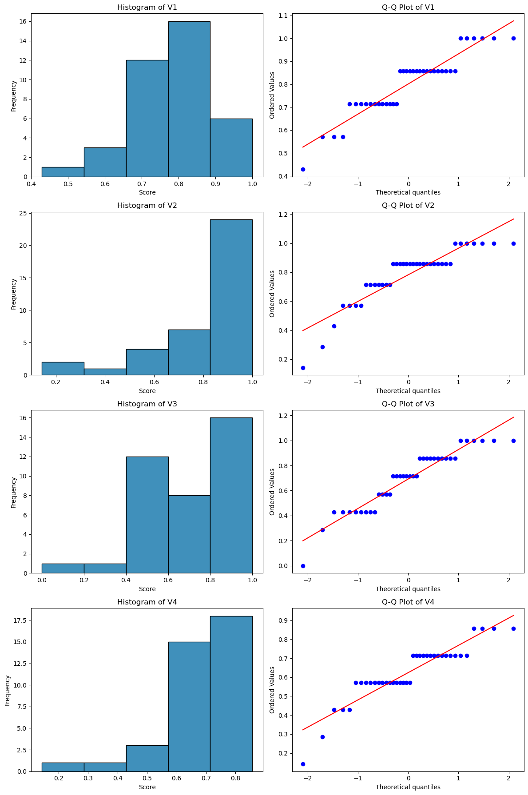
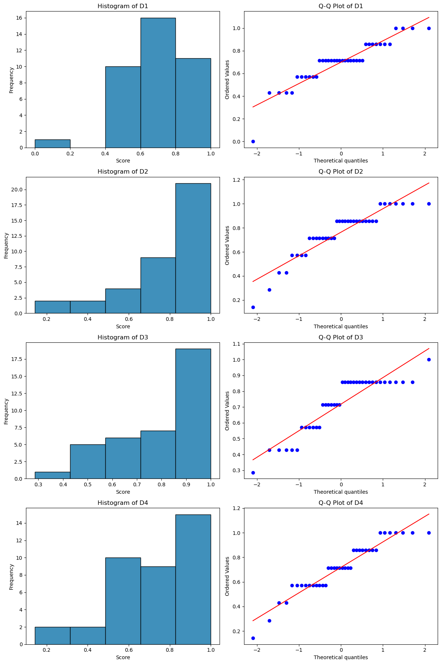
Friedman tests on base data
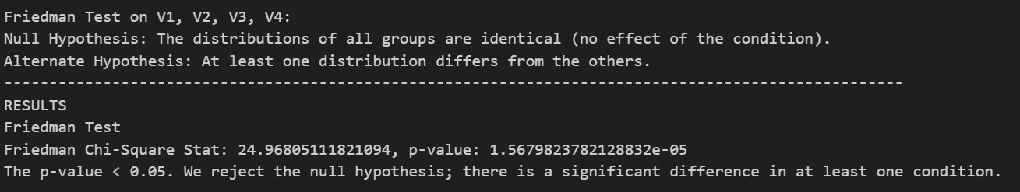
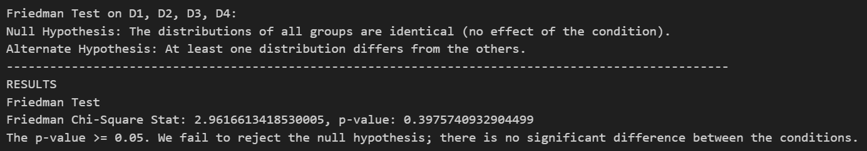
Distribution of base data
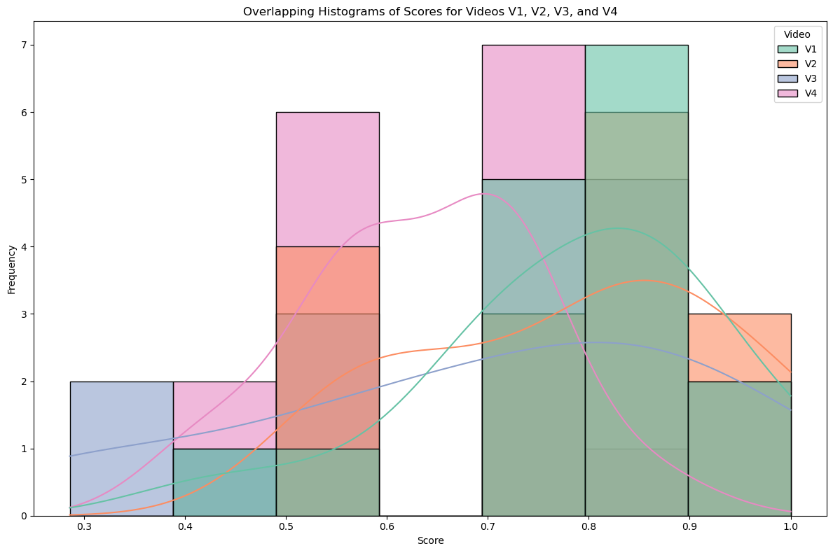
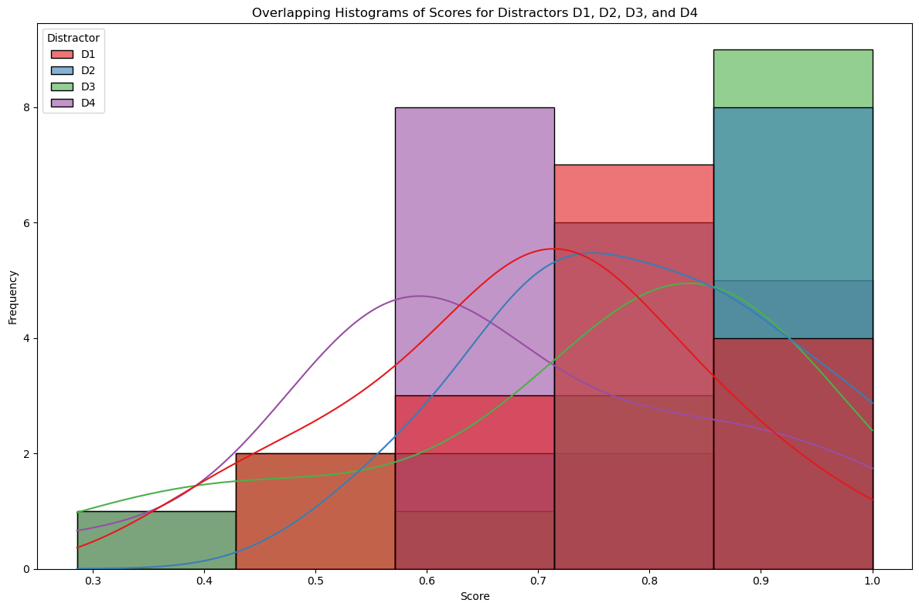
Significance test for high and low social media usage
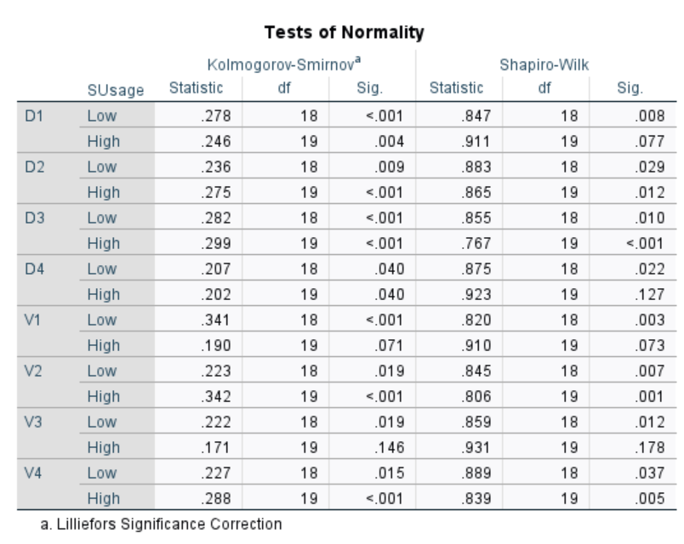
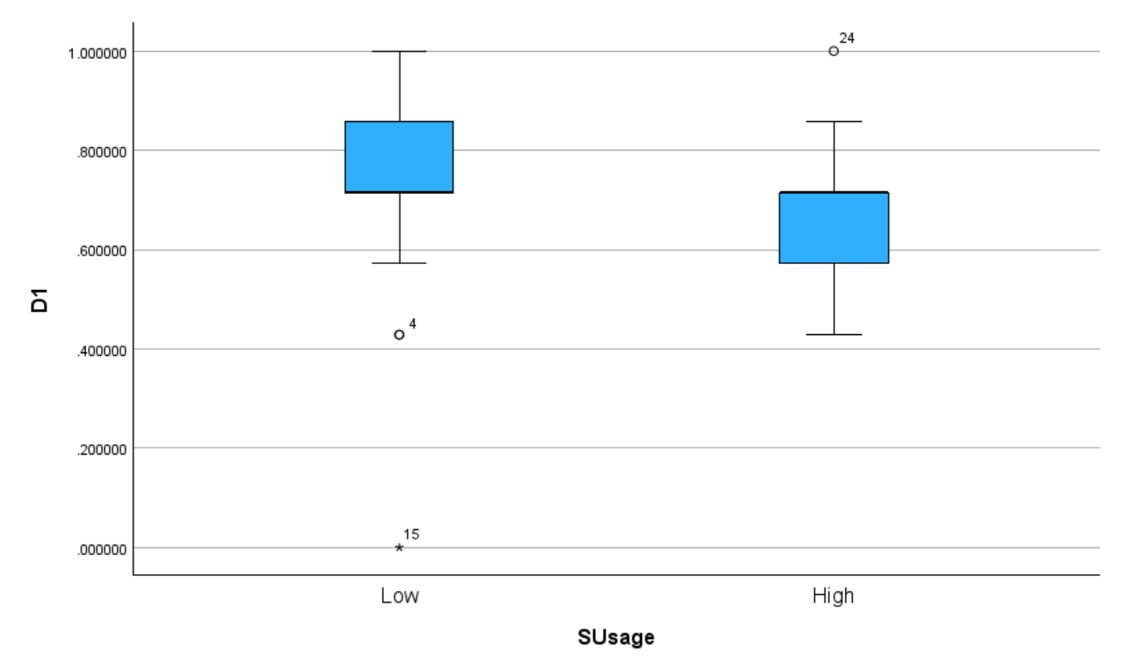
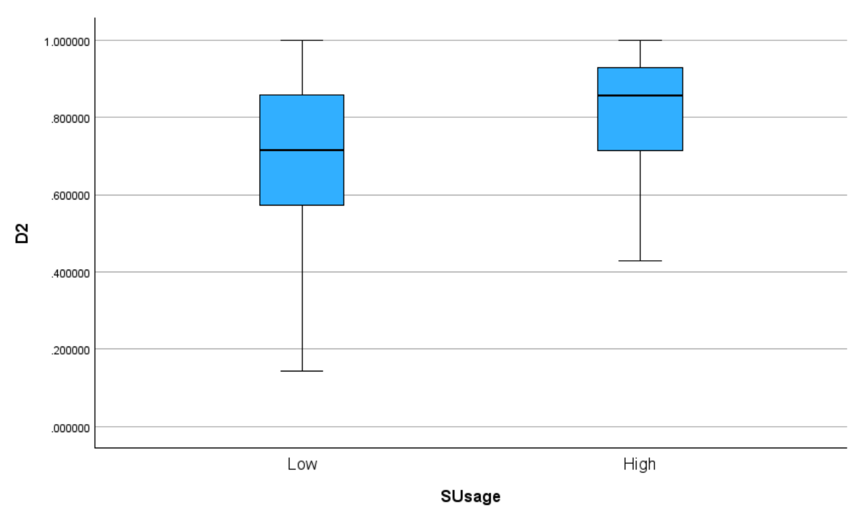
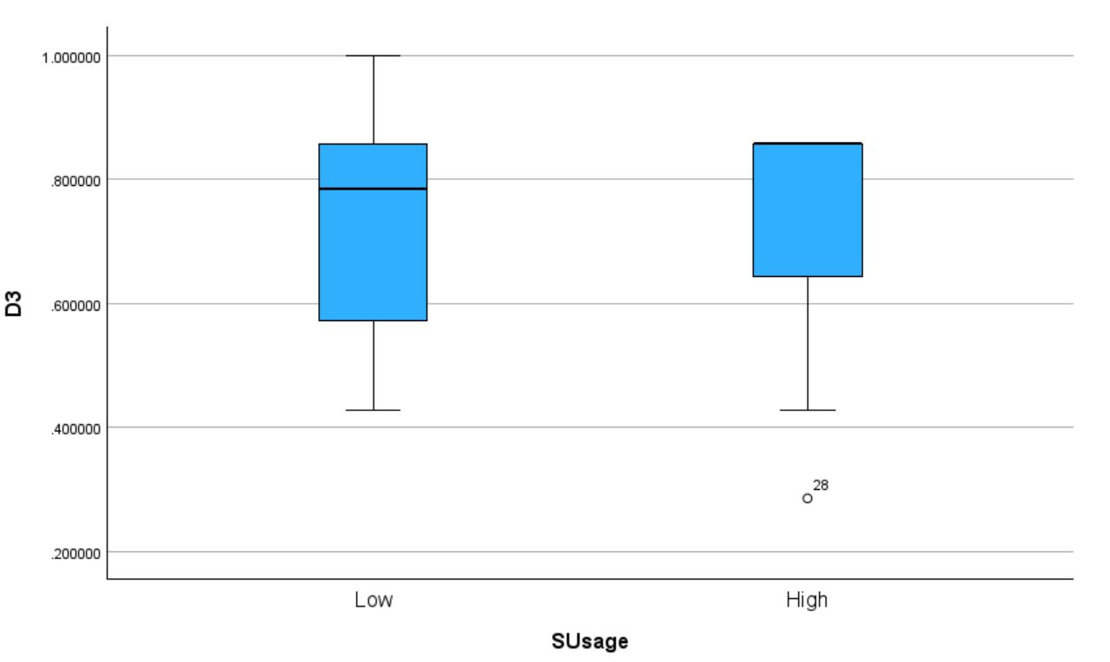
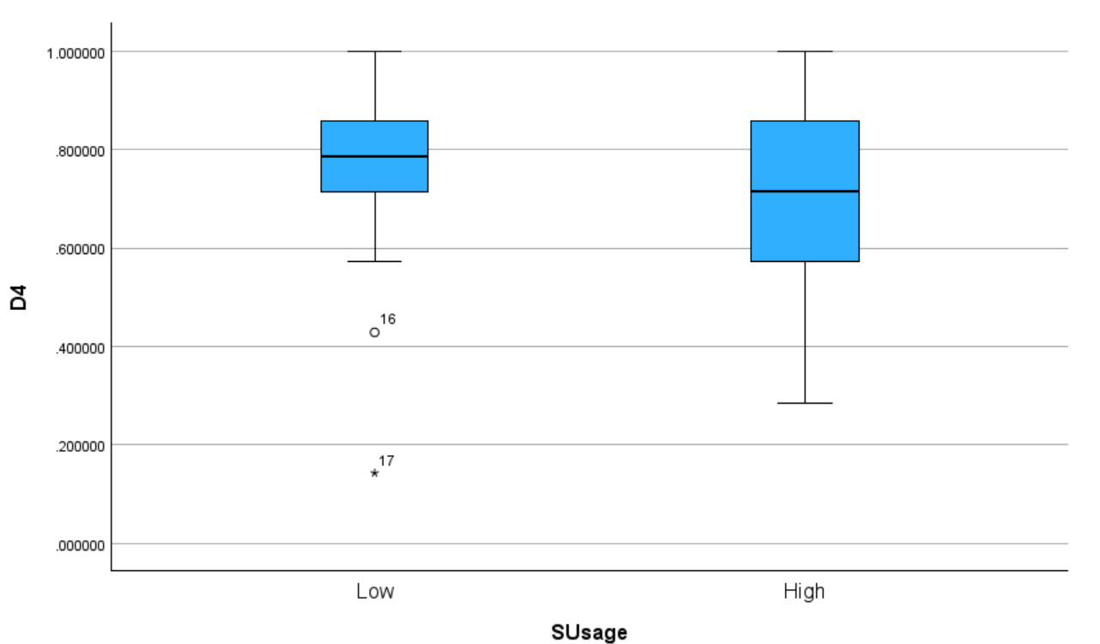
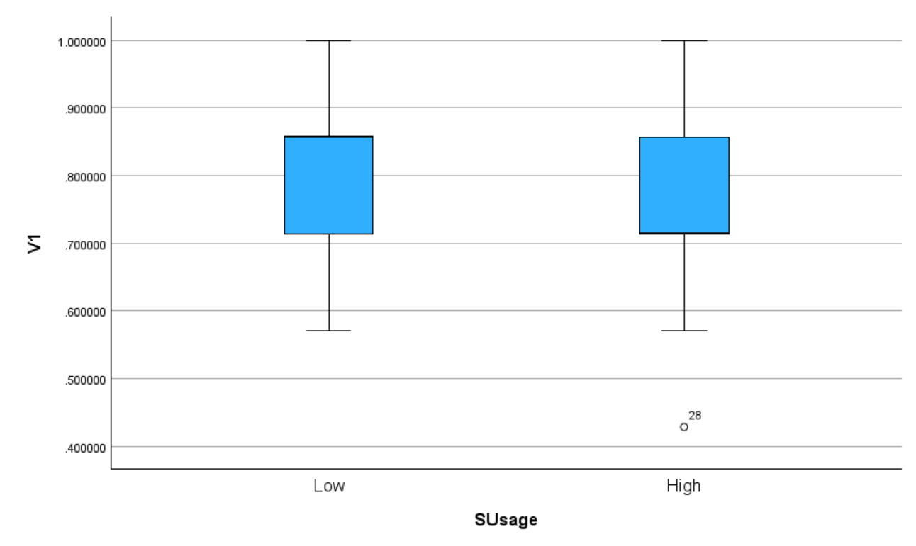
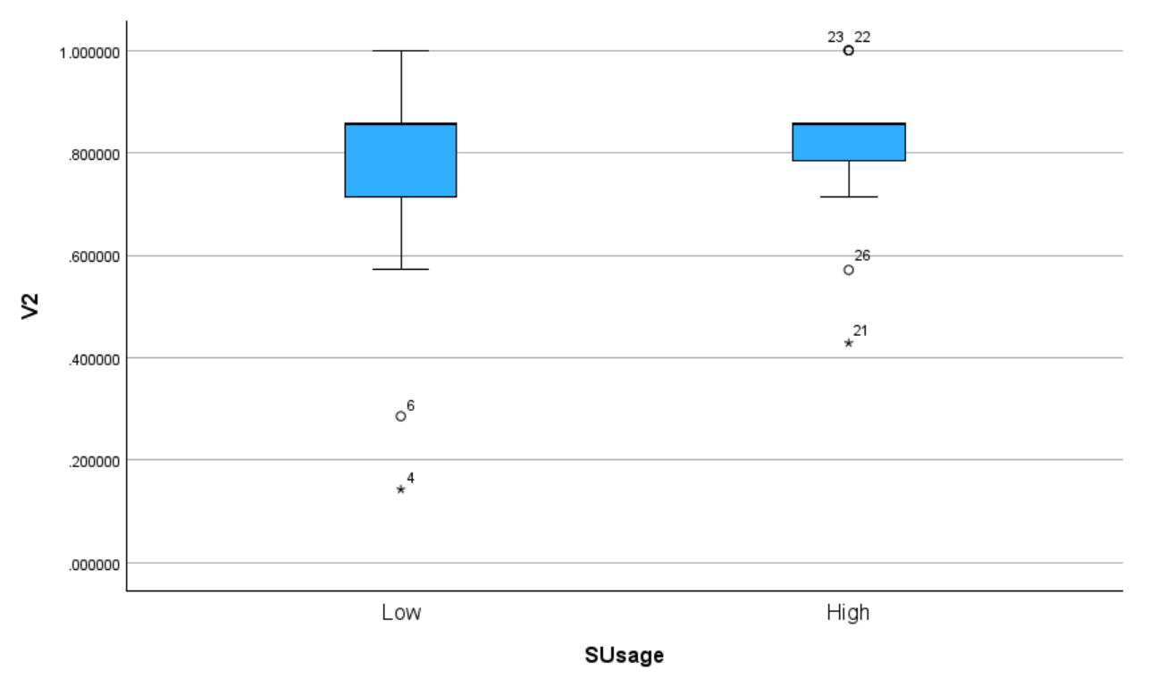
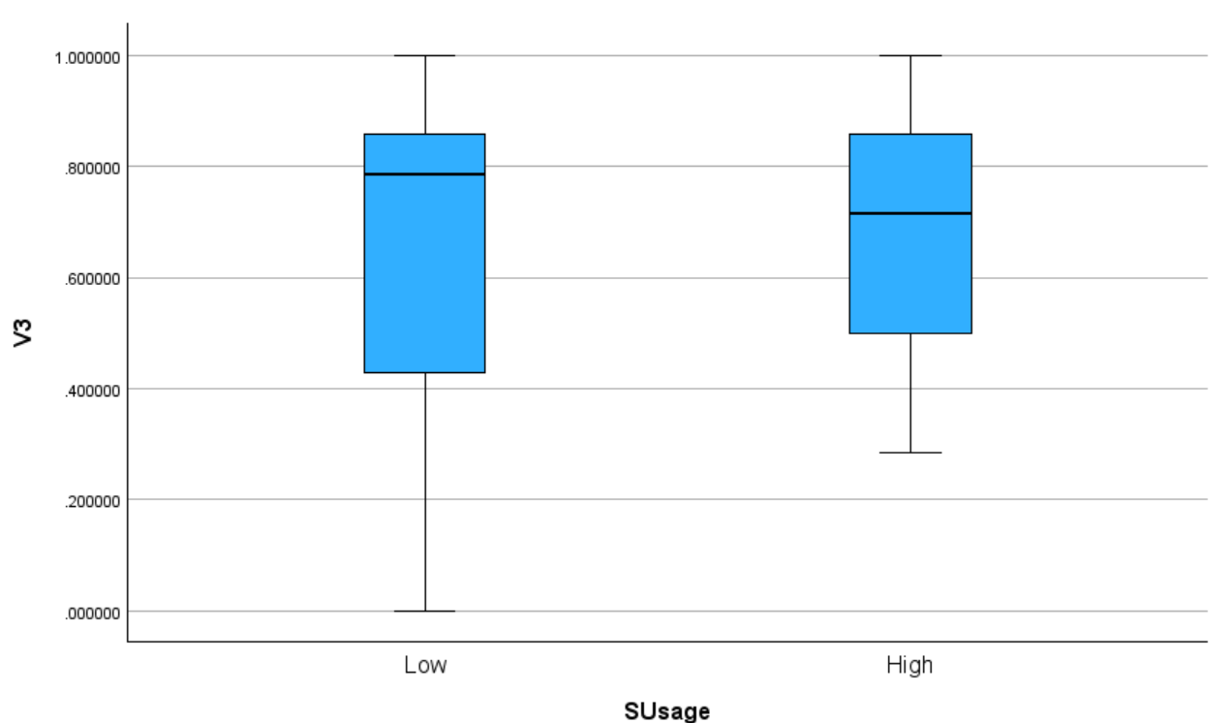
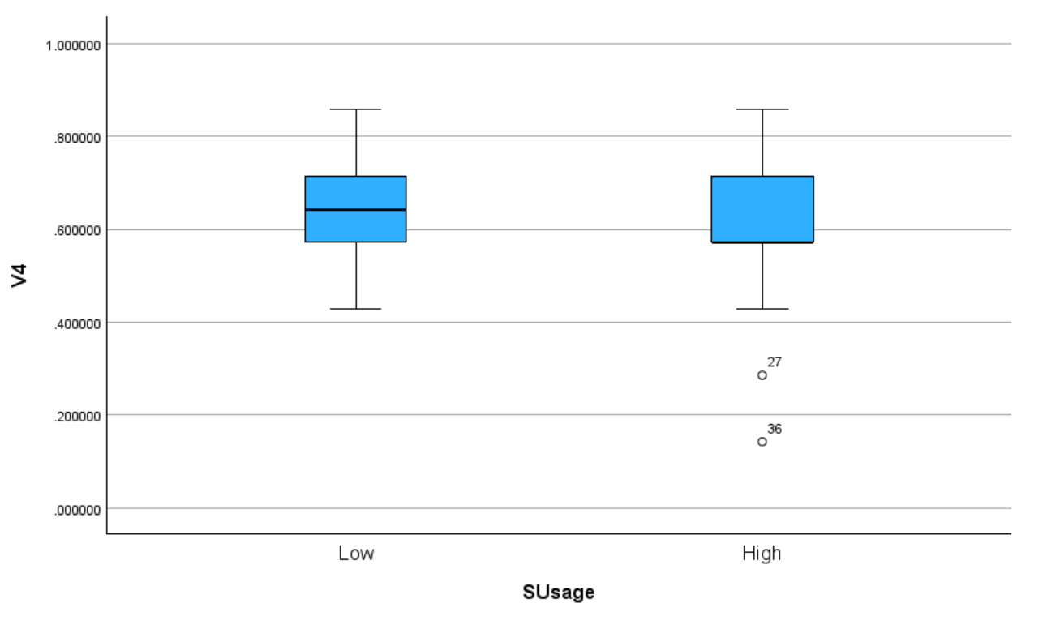
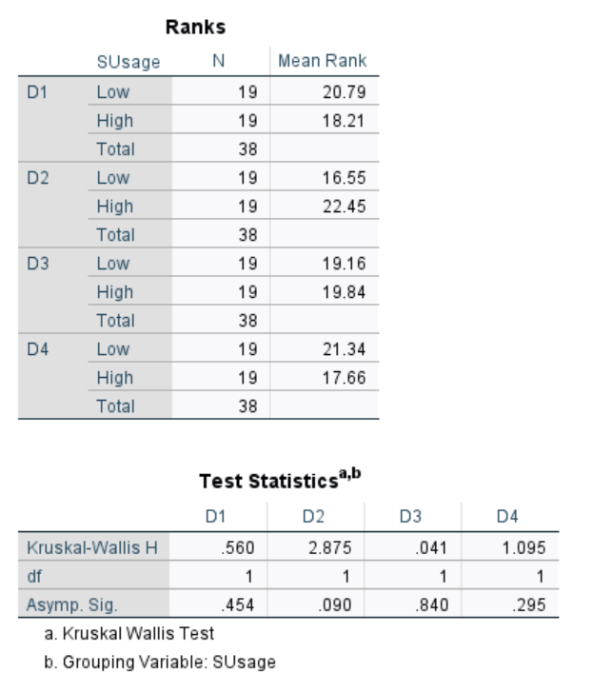
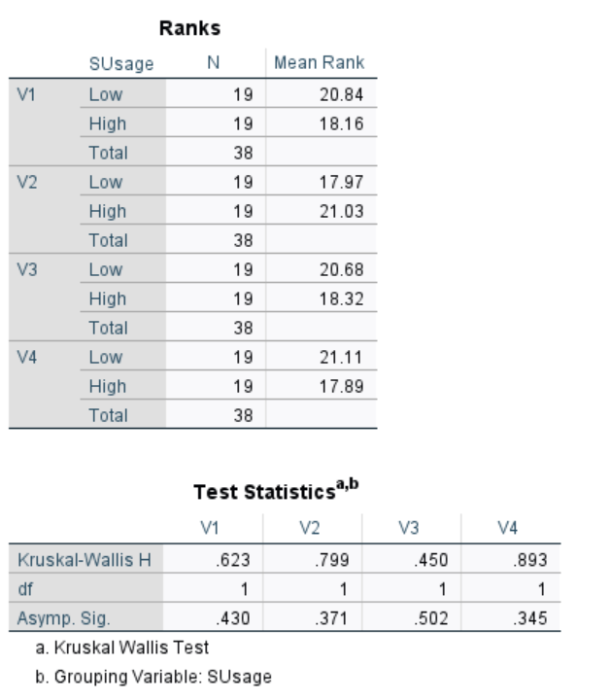
Appendix 2 raw data and encoding/statistical test code for both within subject and between subjects
1903299 phy555 unit 2.zip

